Talbot specialist school – Curriculum statement 2022-23
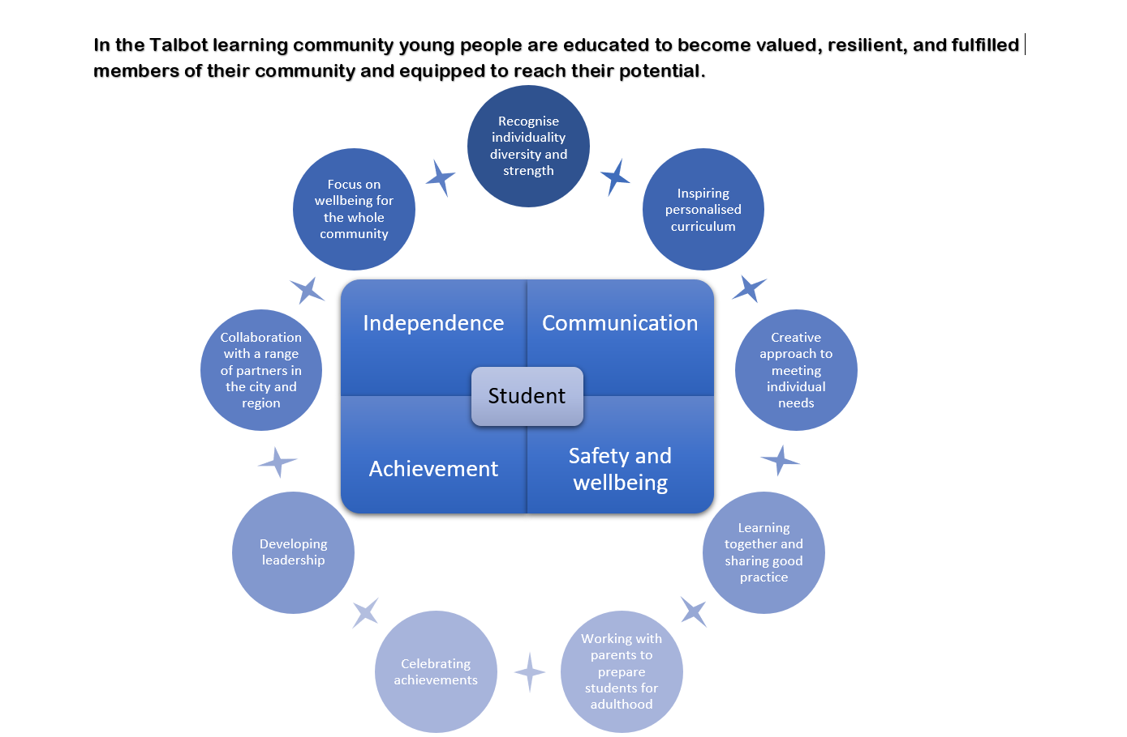
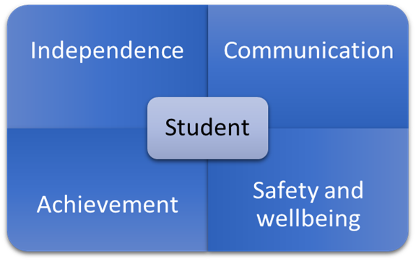
Our curriculum follows three Pathways
Pathway 1 – Informal

Pathway 2 – Semi-formal

Pathway 3 – Formal
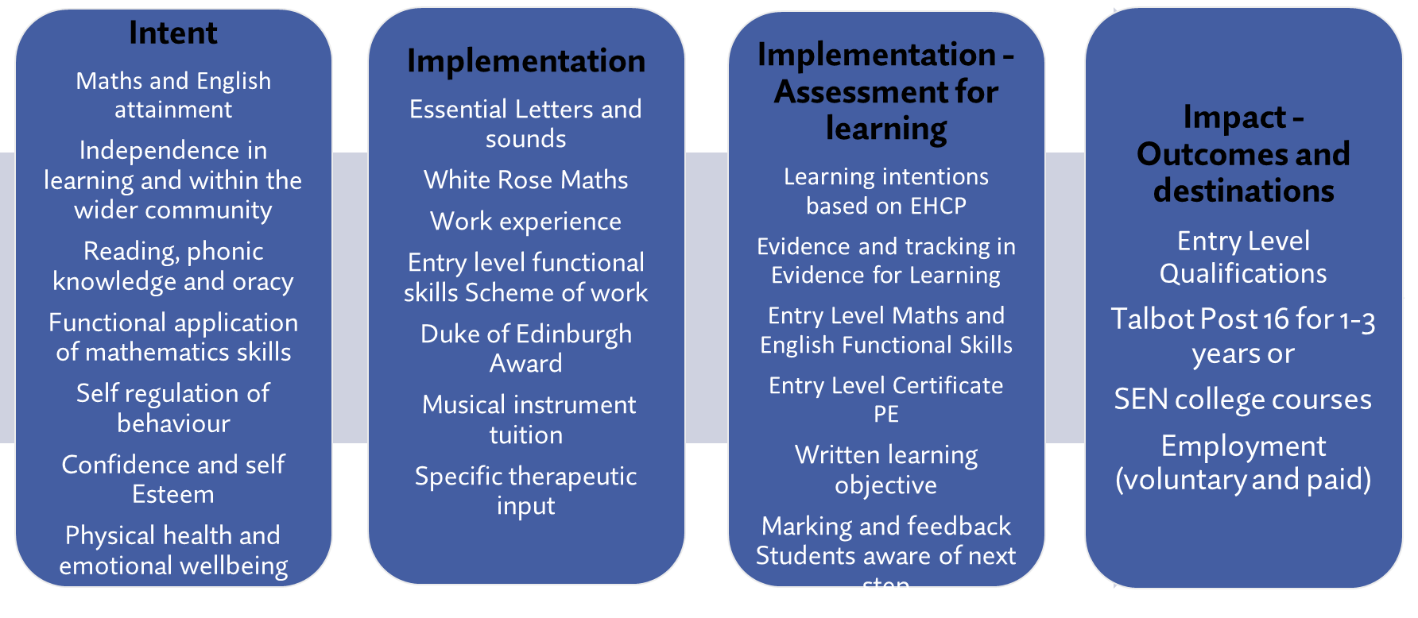

Implementation
The curriculum in Phase 1 (Y7-8) and Phase 2 (Y9-11) is delivered according to the 3 Pathways outlined above.
The Deputy Headteacher has responsibility for the whole curriculum. There are Leaders of Learning for the following areas; English and Communication, Mathematics, Creative and Enrichment and Pathway 1. These Leaders of learning shape the curriculum, provide guidance and support to teachers, and manage the resources for their area. The Leaders of learning for Phase 1 and 2 lead the organisation to facilitate curriculum delivery and learning within their department.
Curriculum offer lead by Individual students EHCP Outcomes
Pathway 1 | Pathway 2 | Pathway 3
Cross curricular delivery around a termly theme. (Wide range of themes provide experience and guidance to teachers)  Incorporate extensive repetition  Discrete sessions around Physical wellbeing. | Delivery around a termly English and Humanities theme.  Other subject areas linked to theme as appropriate for the class.  Lessons based around familiar routines with structured variations to promote learning.  Discrete sessions around Physical wellbeing. | Subject specific with discrete lessons.  Combined English and Humanities termly theme but lessons may be discretely timetabled to ensure coverage.

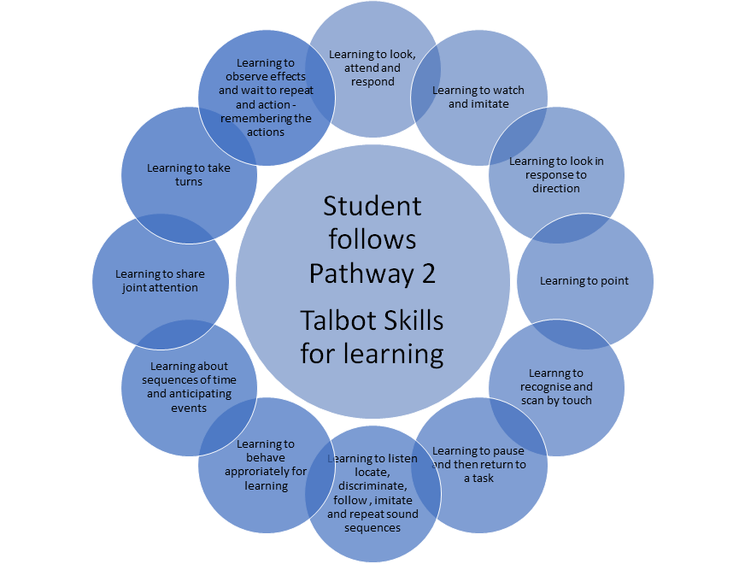
How the aspects link to subjects and intended learning
Independence | Communication
- Throughout the curriculum  - One of learning intention descriptors  - Focus of Transition learning intentions  - Promoting independence unit of Phase 1 citizenship award  - Taught lesson in Phase 2  - Duke of Edinburgh award  - Work Experience/Work related learning  - Eating and drinking skills  - Cooking lessens  - MATP – functional movement | - Throughout the curriculum  - One learning intention for communication  - Communication and Independence and communication and interaction lessons for Pathway 1  - Communication and interaction for Pathway 2  - Current affairs lesson Pathway 3  - English lessons  - Communication HLTAs  - Student council  - Information coffee mornings for parents.
Achievement | Safety and wellbeing
- Engagement  - Skills for learning  - Subject lessons and accreditations  - English (Entry level)  - Reading and Essential letters and sounds (Phonics)  - Maths (Entry level)  - Science  - Humanities  - Outdoor learning  - PE (Entry level)  - Citizenship award – Phase 1  - Duke of Edinburgh  - Swimming awards, Winstrada – rebound, MATP | - Underpins everything  - Nurture provision  - Citizenship Award, including Health week – Phase 1  - Nurture and Wellbeing lessons -Phase 2  - Enrichment lessons – Phase 2  - RHSE including Sex and relationships education and Online Safety  - Work with Physiotherapists, Occupational therapist.  - Student welfare team of HLTAs  - PE  - Outdoor learning  - Working with SALT re eating and drinking
Timetable Headings
Pathway 1 |  | Pathway 2 |  | Pathway 3
Phase 1
Communication and independence | 5 | Communication and interaction | 1 | English | 3
Topic  - Communication and interaction  - Creativity and exploration (including music)  - Cognition and learning | 6 | English (with Humanities) (Topic links to other curriculum areas where possible) | 3 | History/Geography | 1
 |  | Reading | 15 min per day | Current affairs | 1
 |  | Maths | 3 | Reading | 15 min per day
 |  | Art | 1 | Maths | 3
Physical wellbeing  - Hydrotherapy  - Rebound Therapy  - Move/MATP programme  - Physiobods  - Dance massage | 5 | Music and dance | 1 | Art | 1
 |  | Science | 1 | Music and dance | 1
 |  | PE | 1 | PE | 1
 |  | Swimming | 1 for some  classes | Outdoor learning | 2
 |  | Talbot citizenship award | 3 | Science | 1
 |  | PHSE/RSE | 1 | PE | 1
 |  | Cooking | 1 | Talbot Citizenship award | 3
Sensory cookery | 1 | Outdoor learning | 1 | PHSE/RSE | 1
Outdoor learning | 1 | Assembly | 1 | Cooking | 1
Citizenship | 1 |  |  | Assembly | 1
Assembly | 1
Phase 2
Communication and independence | 5 | Communication and interaction | 1 | Current affairs | 1
- Topic  - Communication and interaction  - Creativity and exploration  - Cognition and learning | 6 | English (with Humanities) (Topic links to other curriculum areas where possible) | 3 | English | 4
 |  | Reading | 15 min per day | Reading | 15 min daily
 |  | Maths | 3 | Maths | 3
 |  | Science | 1 | Science | 1
 |  | PE | 1/2 | PE | 1
 |  | Swimming | 1/2 for some classes
 |  | PHSE/RSE | 1/2 | PHSE/RSE | 1
- Physical wellbeing  - Hydrotherapy  - Rebound therapy | 3 | Cooking | 1 | Cooking | 1
 |  | Outdoor learning | 2 | Outdoor learning | 2
 |  | Assembly | 1 | Assembly | 1
 |  | Nurture and wellbeing | 1 | Nurture and wellbeing | 1
 |  | Independence | 1 | History and Geography | 1
Sensory cooking | 1
Outdoor learning | 1
Enrichment | 2
Nurture and wellbeing | 1
Assembly | 1

