Talbot
Specialist
School Uniform

You can view our School Uniform Policy on the Talbot School website – www.talbotlearningcommunity.org.uk  Our school’s uniform  We encourage pupils to wear:  - A purple sweatshirt with school logo  - A white polo shirt  - Black trousers, jogging bottoms or skirt  - Suitable swimwear  - Minimal jewellery  - Safe and sensible footwear  Uniform can be purchased from:  Pinders Schoolwear  pindersschoolwear.com  0114 2513275  Retail Outlets  East Mall, Peak Square  Crystal Peaks Shopping Centre  Sheffield, S20 7PQ  Or  Old Town Hall  1 Howard Street  Rotherham, S65 1JQ | 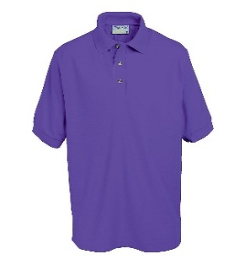Polo Shirt 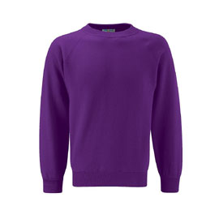 Sweatshirt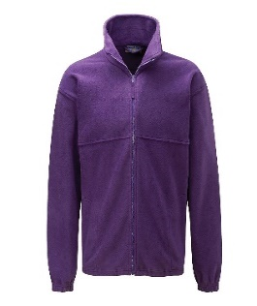 Fleece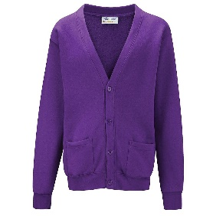Cardigan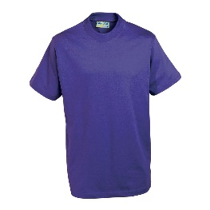 P E shirt 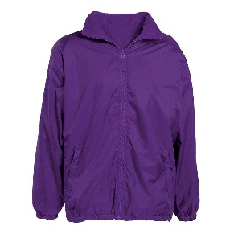Reversible Coat

