Talbot
Specialist
School
Pinders Schoolwear  School Uniform can be ordered from  Pinders Schoolwear by the following options:  Website: pindersschoolwear.com  Telephone orders at Pinders: 0114 2513275  Pinders Shop:  Crystal Peaks shopping centre  and  Mansfield Road  Aston  Sheffield  S26 2BS  0114 2513275  Delivery to school is free of charge  Delivery charge to home is £6.00 | 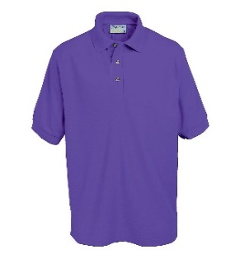Polo Shirt 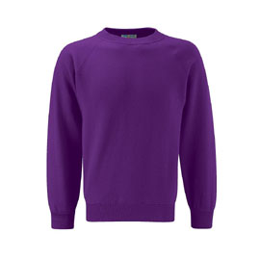 Sweatshirt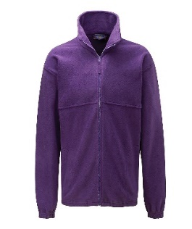 Fleece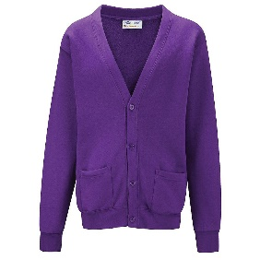Cardigan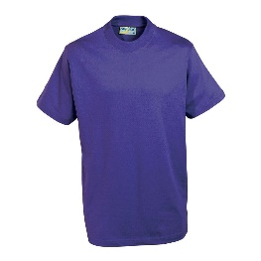 P E shirt 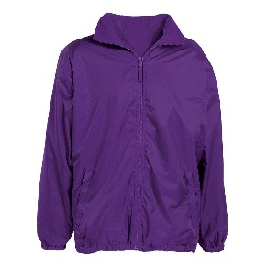Reversible Coat

