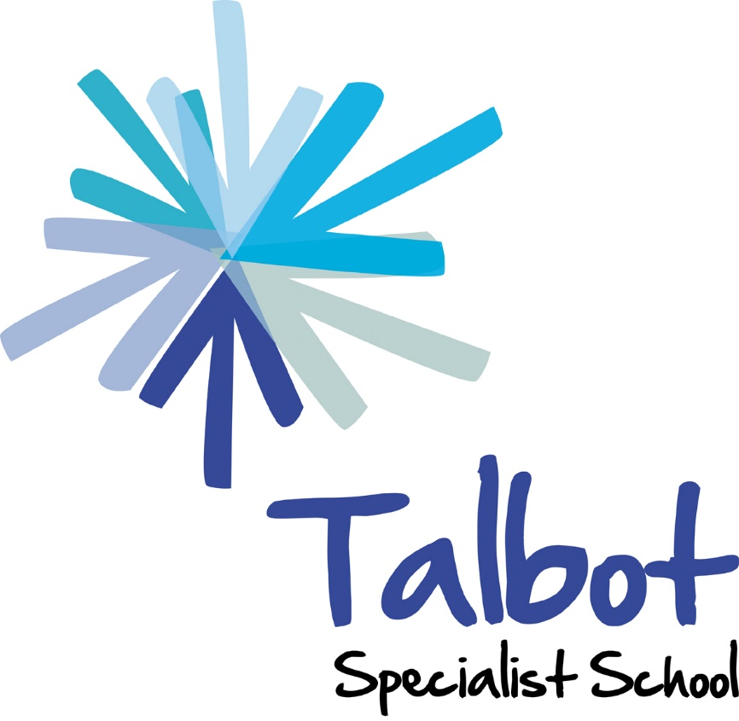

Assessment Policy

2020/21

RATIFIED: Mark Coppel Chair of Governors

Date ratified: February 2021
Review: February 2022

Talbot Specialist School

Assessment Policy

Mission Statement

In the Talbot learning community young people are educated to become valued, resilient and fulfilled members of their community and equipped to reach their potential.

Introduction

At Talbot Specialist School our aim is to enable all our students to experience and participate in learning and teaching which will equip them for their future lives as adults and support each student in reaching their full potential. Central to this is the delivery of a curriculum which is innovative, flexible, person centred and relevant to the challenges and opportunities which our students will encounter as they leave school. Our curriculum is delivered in 3 distinct pathways according to learning need (See Curriculum Statement). Our assessment system reflects the pathways with approaches which are designed to assess the learning which is taking place.

This Assessment policy considers the diverse learning needs and cultural diversity of each of our pupils and builds on the strengths, aspirations and individuality which they bring to our school community.

Aims of the school:

• Valuing all members of the learning community and recognising their individuality, diversity and strengths
• Developing and continuously assessing an aspirational and personalised curriculum which challenges and inspires learners
• Recognising and responding to the needs of each and every student with innovation and creativity
• Providing opportunities and high-quality professional development to build on the school’s continued success
• Being creative and responsive in supporting our students and their parents in preparation for adulthood and life after Talbot
• Celebrating achievement at every opportunity to value the diversity of our learners
• Having excellent and aspirational leadership at all levels
• Being outward facing and building on our reputation for excellence
• Creating a supportive environment that nurtures wellbeing across the community

Aims of Assessment

- To involve students in their learning by ensuring they understand what they are learning and where they are in their learning.
- To involve students in their learning by providing opportunities for peer and self-assessment.
- To raise aspirations of students, teachers and parents and carers.
- To show our students that their work is valued and to celebrate their achievements.
- To set challenging targets which enable students to make outstanding progress in their learning.
- To identify areas of strength and difficulty to inform the next steps in learning.
- To inform personalisation of learning through differentiation.
- To identify any barriers to learning and the support/intervention needed to overcome them.
- To provide information to improve teaching and learning by informing progression in planning and curriculum delivery.
- To measure and analyse the impact of curriculum developments, interventions and support upon student progress.
- To inform all stakeholders about student progress and achievement.

Assessment for Learning Process (Formative assessment)

A range of the strategies listed in the diagram above are used, based on individual student learning need.

Assessment is used in the classroom to raise student achievement. Students will make the most progress if they understand the aim of the learning, where they are in relation to this aim and what they need to do to achieve this aim.

The format of the assessment for learning strategies depends upon the learning needs and learning levels of the individual students. The emphasis is upon meaningful and relevant strategies which enable each student to make progress.

Staff develop high quality, trusting relationships with our students and this is a vital factor in determining the effectiveness of feedback. The staff know the students well and are skilled in identifying motivating and engaging ways of presenting information and responding to students’ learning.

Students Following Pathway 1 (informal curriculum)

  - Teachers use objects and actions to communicate to students that a specific type of learning/interaction is about to happen or is happening.

Students Following Pathway 1/2

  - Teachers use objects and visuals to promote autonomy of students. Students begin to understand some of the elements of good learning and a simple set of criteria to assess and celebrate achievements.

Students Following Pathway 2 (semi-formal curriculum)

  - Teachers use the written word and key symbols to reflect and support students to understand their learning and to develop some autonomy. Students begin to use symbols to represent good learning.

Students Following Pathway 3 (formal curriculum)

  - Teachers share learning objectives in written form with key symbols. Students can follow steps to learning to develop autonomy. They begin to reflect with growing independence on how they achieved using supportive materials. Teachers model how to unpick a process.

Marking

Effective marking is an essential part of the education process. At its heart, it is an interaction between teacher and pupil: a way of acknowledging pupils’ work, checking the outcomes and making decisions about what teachers and pupils need to do next, with the primary aim of driving pupil progress. This can often be achieved without extensive written dialogue or comments.

Effective marking is:
- Meaningful: Marking varies by group, subject and what works best for the pupil and teacher in relation to any particular piece of work. Teachers are encouraged to adjust their approach as necessary and trusted to incorporate the outcomes into subsequent planning and teaching.
- Manageable: Marking practice is proportionate and considers the frequency and complexity of written feedback, as well as the cost and time-effectiveness of marking in relation to the overall workload of teachers.
- Motivating: Marking should help students to progress. This does not mean always writing in-depth comments or being universally positive: sometimes short, challenging comments or oral feedback are more effective.

Marking guidelines
- All work is marked for students working within Pathway 3 (formal curriculum).
- Teacher/TA marking is with a green pen.
- This marking takes place with them wherever possible and focuses upon their success against the learning objective and any improvements needed. It may also relate to an individual learning intention.
- This can be a written record of verbal feedback and students are given the opportunity to respond and this can be recorded.
- Next steps are clearly identified.
- The language/communication strategies we use in marking are clear and students have the opportunity to self-evaluate following verbal and written feedback.
- This may be in the form of a tick against success criteria or a written comment. Student feedback will be completed using a purple pen.

Summative Assessment

Pathway 1 & 2 (Informal and semi-formal curriculum)

Students are assessed using MAPP (Mapping and Assessing Personal Progress). This assessment shows detailed and lateral progress towards Learning Intentions related to students EHCP’s and to the changing needs of the individual student. It assesses the development of four aspects of skill using a ten-point scale.

The aspects are:

- Independence
- Fluency
- Maintenance
- Generalisation.

These aspects are not hierarchical and progress in each area will be individual to students and their particular Learning Intentions. Students are set 4 Learning Intentions, twice a year in October and January. They are evaluated in January and July with progress updates in December and April.
In September students are set a Transition Target to support them in moving to new classes and key stages. This is evaluated in October.

Pathway 3 (Formal curriculum

Students are assessed using Birmingham Toolkit for English and Maths. The toolkit supports monitoring and assessment in 14 areas of English and 9 areas in Maths.
In September students are set a Transition Target to support them in moving to new classes and key stages. This is evaluated in October.

New students have baseline assessments, using Birmingham Toolkit at the end of October. Data is then collected at three points during the year in October, February and July. There are 2 further progress updates in December and April.
Students also have 4 Learning Intentions directly linked to their EHCP. These Learning Intentions are set twice a year in October and January.

Monitoring

Regular monitoring of assessment will take place. Monitoring of Assessment for learning is a feature of lesson observation. Students’ work and evidence of progress and achievement is gathered using “Evidence for Learning”. This is monitored alongside the lesson observations. A learning walk will take place each half term by the senior leadership, to monitor assessment and the impact on pupil progress. Middle leaders will regualrly monitor Evidence for Learning for classes throughout school. The Maths and English leaders will also track evidence of progress in their areas.

Jake Shaw
February 2021

