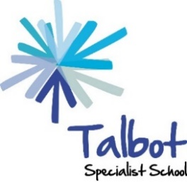 Talbot Specialist School

Remote Learning Strategy January 2021
Guiding Principles
- Contact with our families and students is about supporting the wellbeing of students and families as well as guiding realistic home learning.
- Our students have a diverse range of learning needs and family circumstances, and we need to take these into account to provide an appropriate form of support.
- This an opportunity to develop relationships with our families and gain a greater understanding of how we can work together to best support the students.
- In no way do we want to apply pressure on any parents to deliver learning at home, however there is an expectation that the planned learning programme can continue, and we will support in whatever way we can.
- We will provide activities that support the curriculum and continue learning.
- All staff have a role to play in helping with contacting families and supporting learning.
- There will be communication between teachers, middle leaders and SLT regarding the contact that has taken place and a record will be kept.
- We will use varied methods to communicate with families, considering the wide range of circumstances and to prevent an overdependence on one method if it cannot continue.
- We will consider the accessibility and availability of resources for each family. For example, some families may need paper-based resources sending out. We will provide a laptop for students who do not have access to a digital device.

How we will deliver remote learning
Aims of home learning
- All students receive a full offer of remote learning which can be supported by families
- The home learning offer is differentiated and appropriate and takes into account the individual strengths and learning needs of each student
- Students continue to make progress
- Students have access to the full curriculum

We will do this in a variety of ways, tailored to the needs of individual students and their families.

